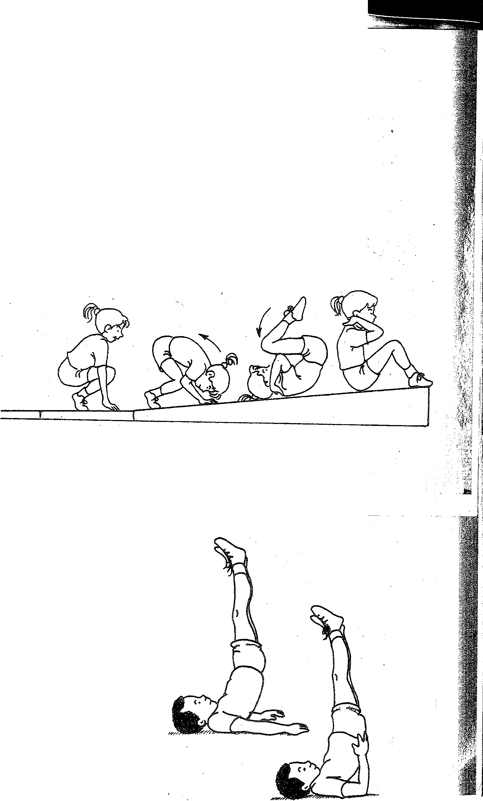
44. Backward roll down incline to tuck

The student starts in sitting position, knees close to ch st
position) on top of the incline with her back to the incline. Her back is rounded, chin is on or near the chest, and hands are bythe ears, palms facing upward and backward. Make sure that the student's elbows poi.ri.t forward and not sideways. Holc:Iing this shape, the student leans backward and rolls down the incline finishing iryttuck position. '
Teaching Tip , . . ; ,. ' .1
If possible, it's a go6ct'ideto introduce incline skills within an existing circuit, because you ID:::l.Y ·haye only one or two inclines. Don't forget to
emphasize arm push. · > · ·

I

11. Shoulder balance .

The student lies on his back, pressing arms and_ha_nds oWn
stretching his body straight above him, and pomting his toes upward. The
student should place the hips over the shoulders and arms and look at the toes.
Teaching Tip . .
During this skill the student should place no· w 1ght
head. Instead the shoulders and arms should bear the weight. !he s dent
can place the arms on the floor for. support, or to make the skill eas1er, he
can place the arms to support the back.

