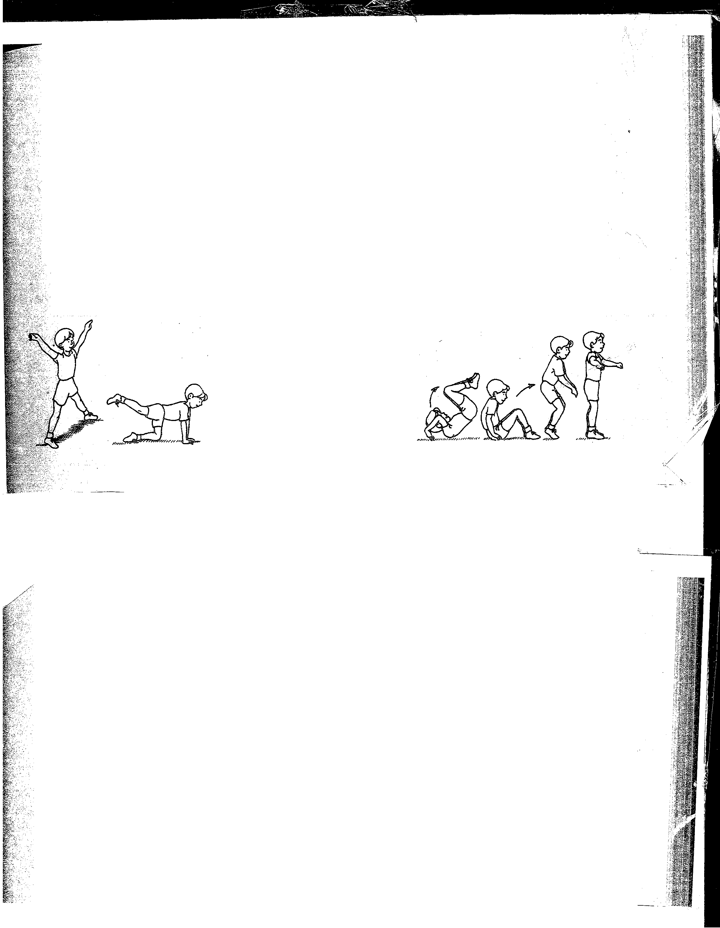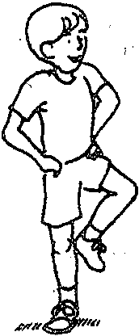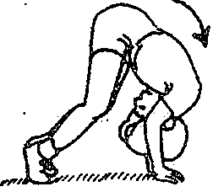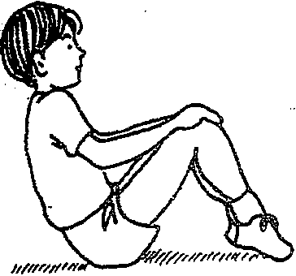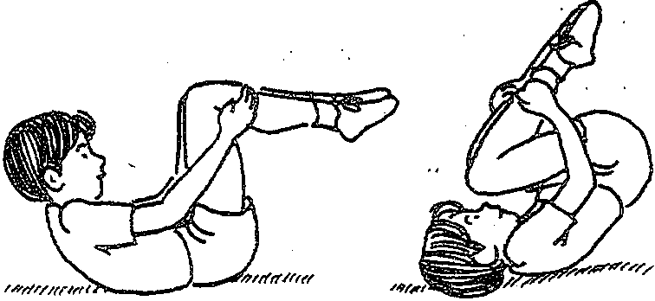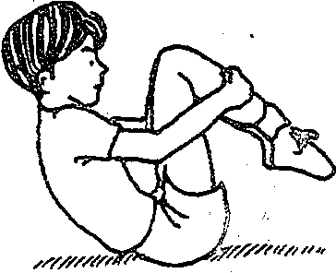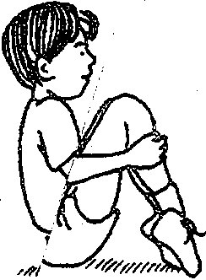TUMBLING PRINCIPLES AND SKILLS 25

45. Forward roll from three different positions
The student begins the forward roll in one of the following positions: a straddle stand, knee scale, or stork stand. The student completes the forward roll as usual except for the starting position. The key points for the roll from these positions are to bend the legs and tuck the head toward the chest. The student should finish the forward roll in aT-stand.

. Teaching Tip . Although three specific starting positions have been selected here, an
alternative would be to have students create their own starting positions. One way to check for safety of the starting positions is to have students
.show you only the starting positions.

---.---------.-·-····-··.·-····---- --------------------·-·-·

TUMBLING PRINCIPLES AND SKILLS 21

36. Back rocker
The student sits on the ground in the tuck sit position. His back is rounded and his chin is on or near the chest. Holdingthis shape, the student lean backward and rocks backward and forward on his back at least twice.
Teaching Tip
To make this skill easier, have students wrap their hands around their legs
as they rock. To make this skill harder, the students can leave the hands
stretched forward toward the knees.

