TUMBLING PRINCIPLES AND SKILLS 23

41. Back rocker with hand touch
The student sits on the ground in the tuck sit position. His-back is rounded, chin is on or near the chest, and hands are by the ears, palms facing upward and backward. Make sure that the student's elbows point forward and not
J
sideways. Holding this shape, the student leans backward and rocks -_
- . backward and forward on his back at least twice; with his hands touching
.•. _ the ground behind his head each time. -
- Teaching Tip ·

•_···--·
for'younger students, have_themimagine that their hands are elephant

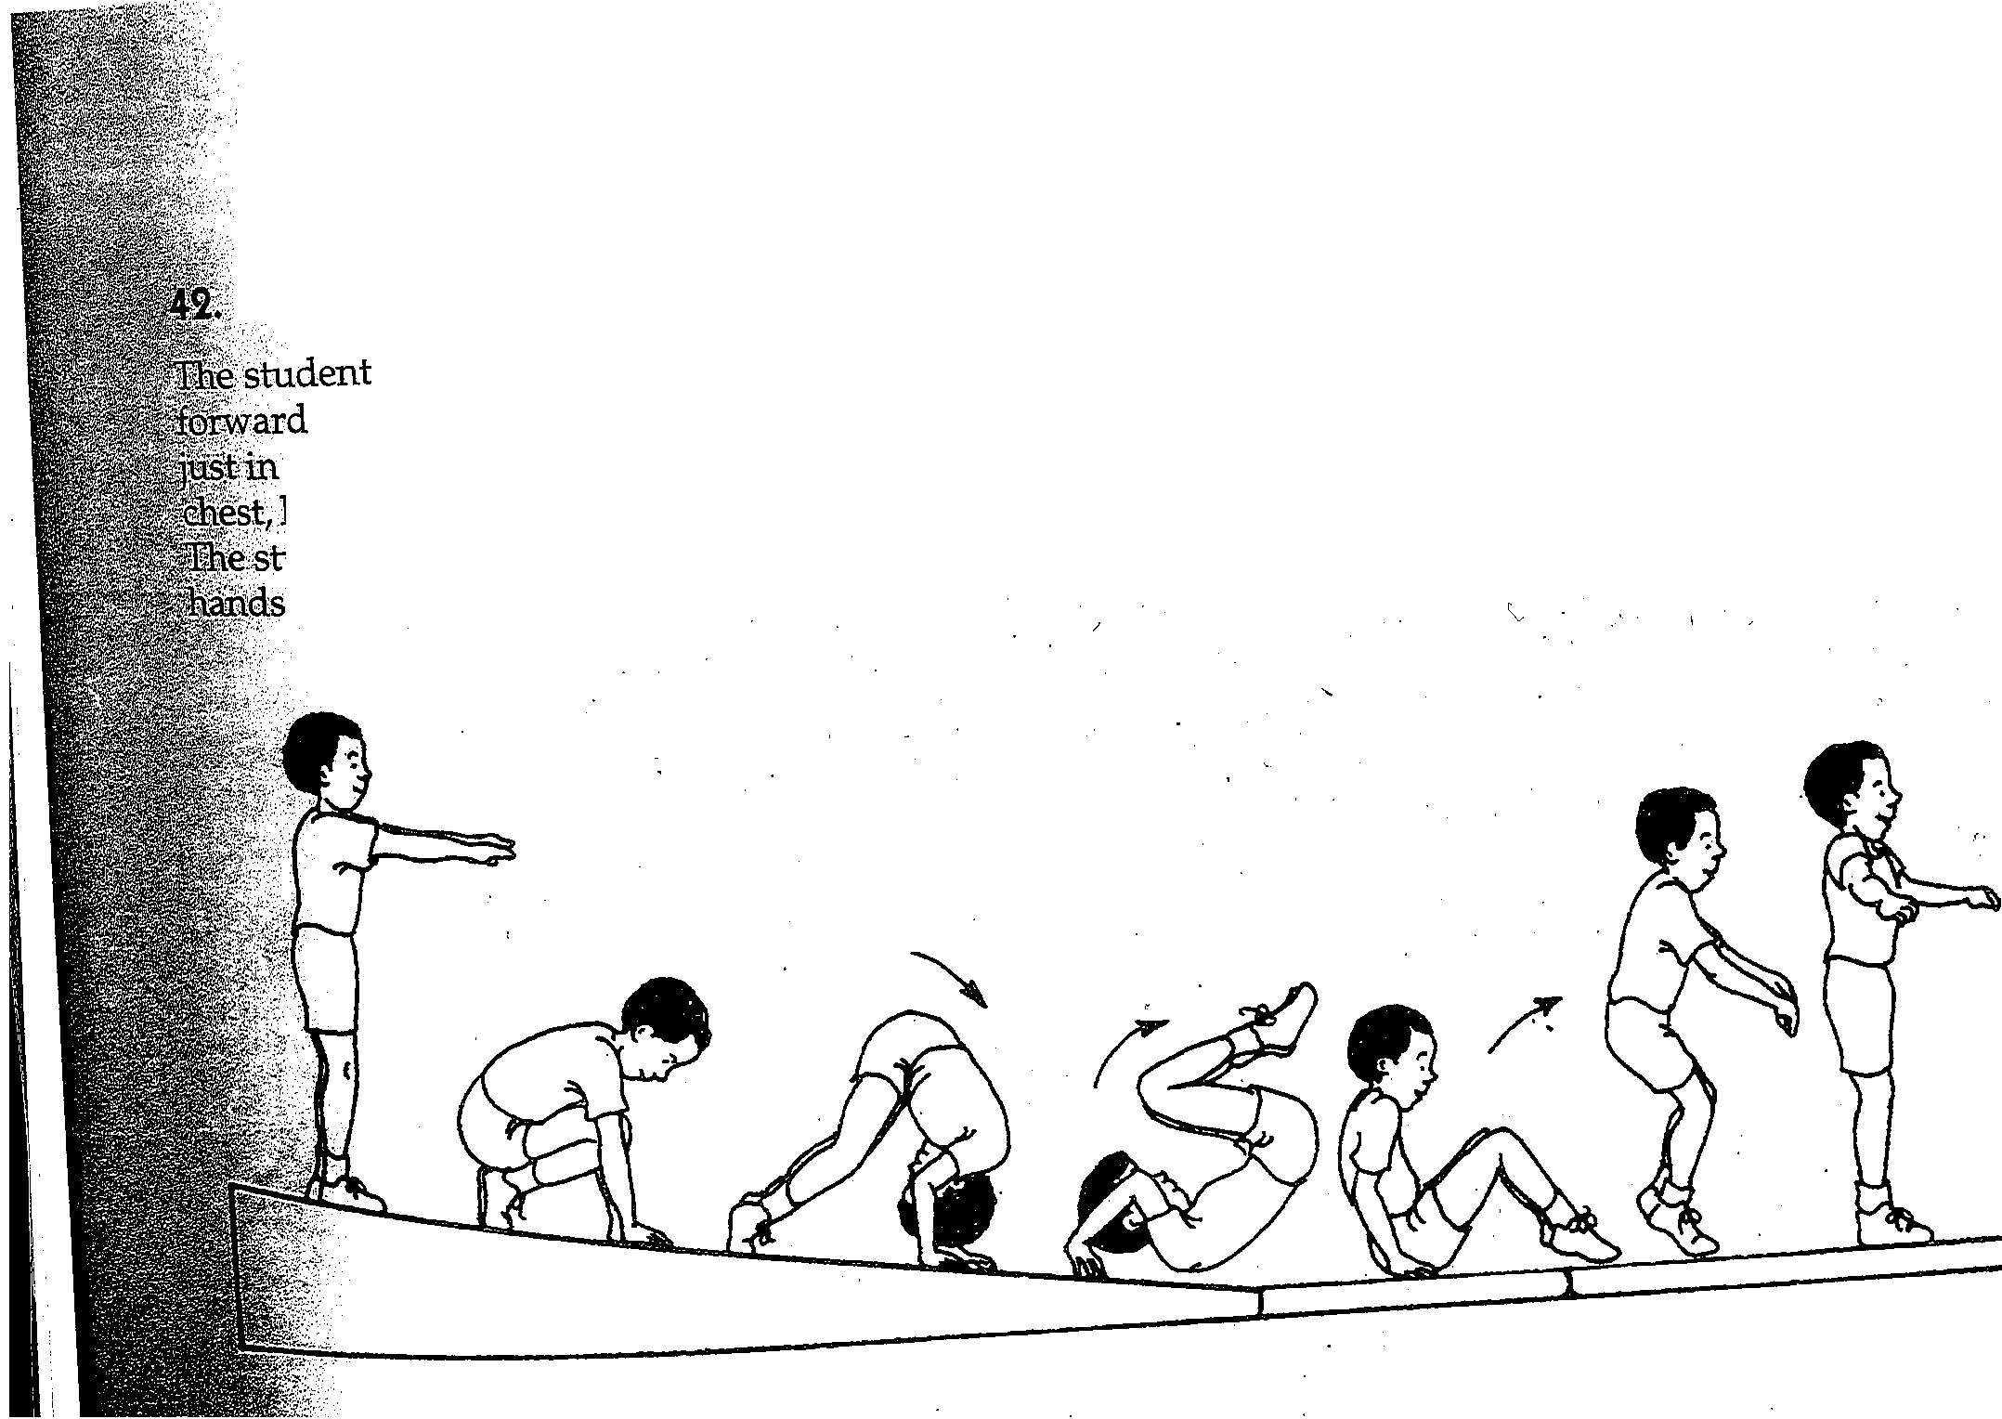• ea,ts and need to stay on theu ears during this skill.

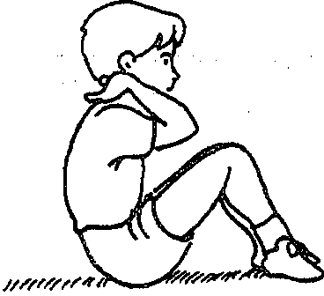( 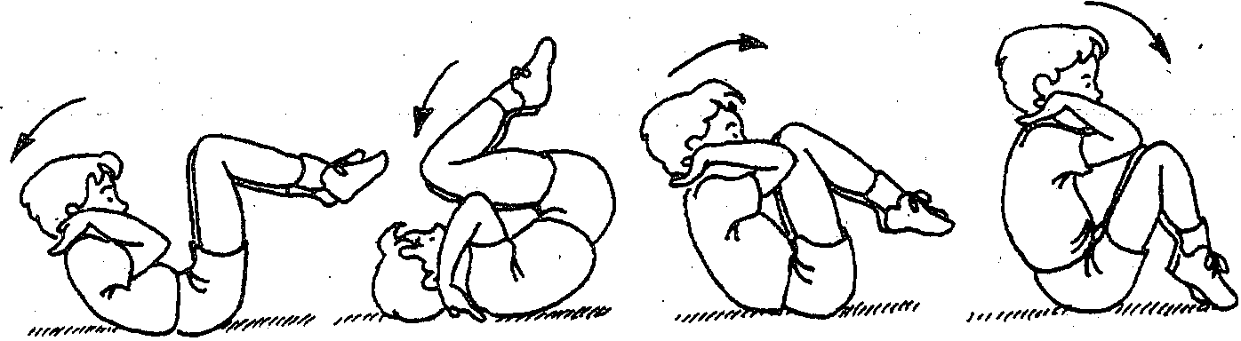

-------· -------

-----------

· forward roll down incline to stand
starts standing tall on top of the incline, stretching the arms horizontally. The student then tucks, placing ands
front of the shoulders. Next the student tucks his head toward his
,., forward, and pushes hard with the legs. This will startte
"""LLJU ..."' rolls forward in a straight line, pushing off the floor.w1th the
while standing up and finishing in aT-stand.

