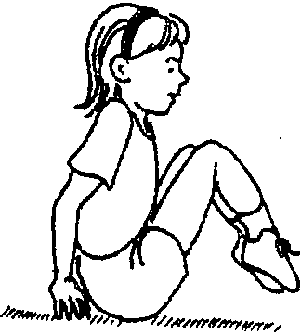

22 TEACHING TUMBLING

39. Forward roll on mat to sit

The student starts standing tall, stretching the arms forward horizontally. The student then tucks, placing hands close to feet but just in front of the shoulders,tucks the head toward the chest,leans forward,and pushes hard with the legs. This will start the roll. As the student rolls over he should maintain the tucked position. The student finishes this skill in a sitting position, with his legs straight on the floor.
Teaching Tip
Introduce the forward roll on mat to sit by reviewing the back rocker and by having each student perform the back rocker to sit on the floor four or five times. Be sure to emphasize hand placement and head tuck. Students should perform this task at least 10 times per class, with rest between each attempt. When you have only a few mats, alternate practices between two · or three students sharing one mat.

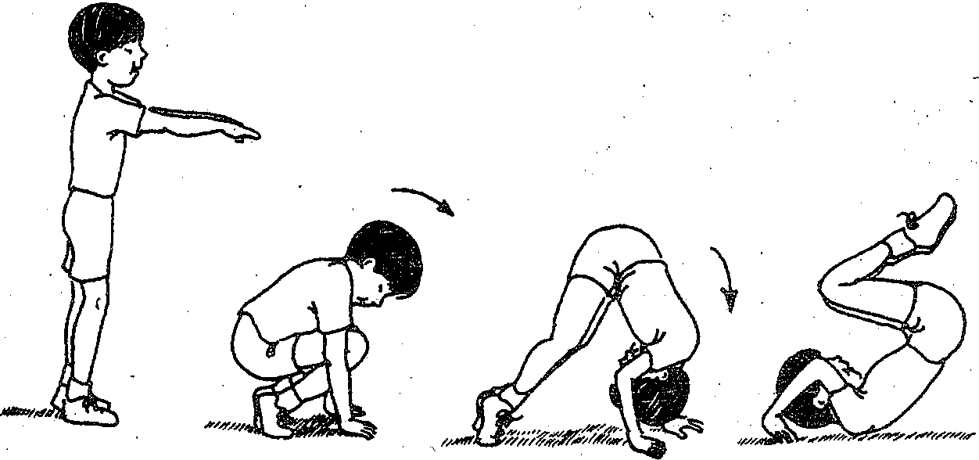

Sit and, spin c-\
' ' )
The tudent 01). th{floor on e1ther side of the hips. The sh1dent lifts er
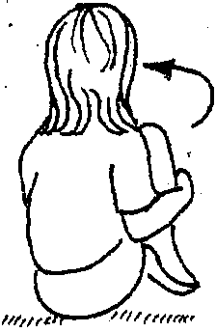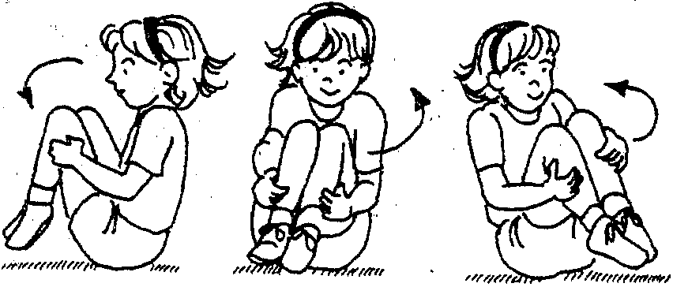hands to spin the body around two or three times. During the spin, the student stays tightly tucked and wraps her hands around the knees. The student should always stay seated (don't spin on the back)..

