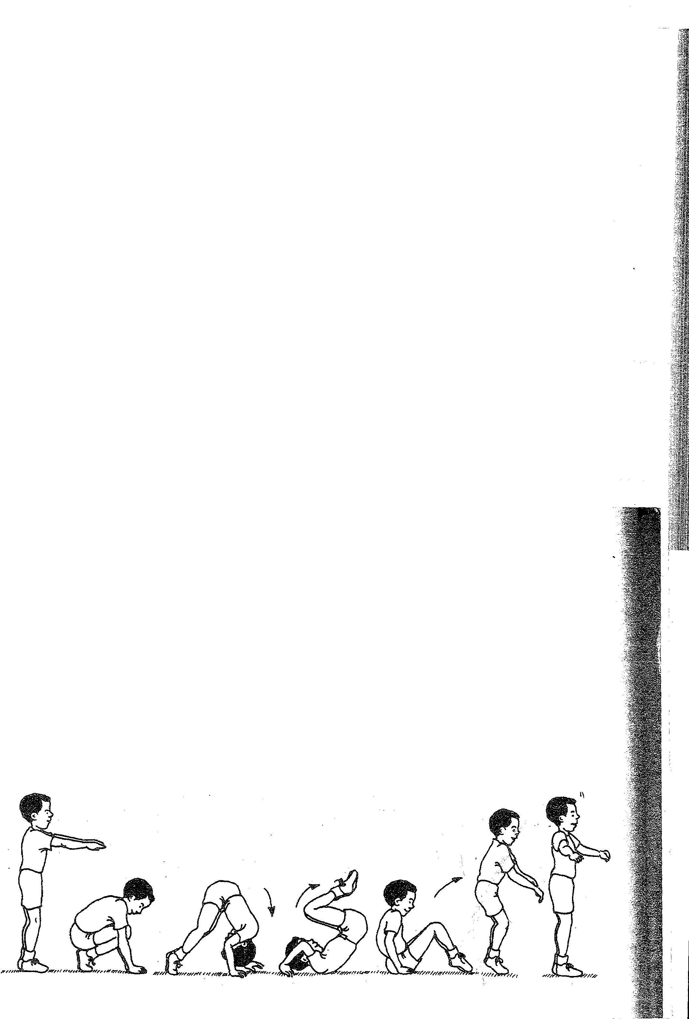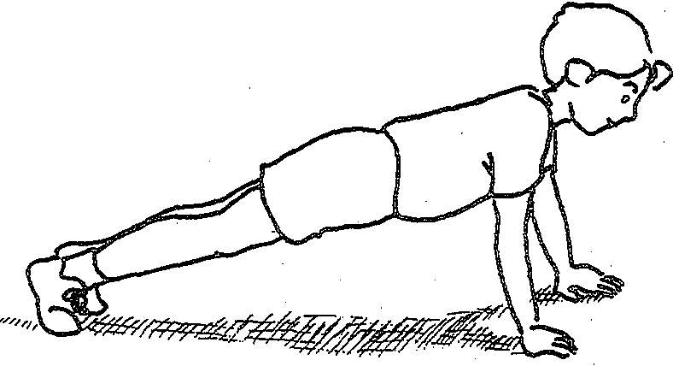21. Front support

The student assumes a push-up_position with straight arms, a straight and firm body (the back slightly curved upward), the legs straight and together, and the eyes looking forward.

22. Kick up to one-leg handstand .

.The student starts in a standing position, stretching arms forward horizon­ tally. The student steps to lunge forward and places her hands on the floor shoulder-width apart. Keeping the back leg· straight, the student kicks upward with it, and simultaneously pushes against the floor with the front leg, straightening it during the push. Finish in either near or momentary
. balance with both legs straight, one vertical (the first leg into the air) and the other horizontal or lower. ·
Teaching Tip
Introduce this skill by demonstrating it, emphasizing the importance of control. Use the following two rules to guide the instruction.
1. Progress from a small kick upward to increasingly larger kicks.

2. Don't have students attempt to kick past the handstand position (or they will fall over). ·
·\,. ; : : '".

24 TEACHING TUMBLiNG

43. Forward roll on mat to stand
. 1'· . •
The student starts standing tall op. the #J.at, stretching the arms forward horizontally. The student then tuei?s, pl ¢ing
front of the shoulders, tucksthehead to ard
pushes hard with the legs. This will star ithe in a straight line, pushing off the floor;i (Vith and finishing in aT-stand. , U?
Teaching Tip .! . . . If you haven't already, it might be time to stop and improve the students' form as they perform the forward roll.

