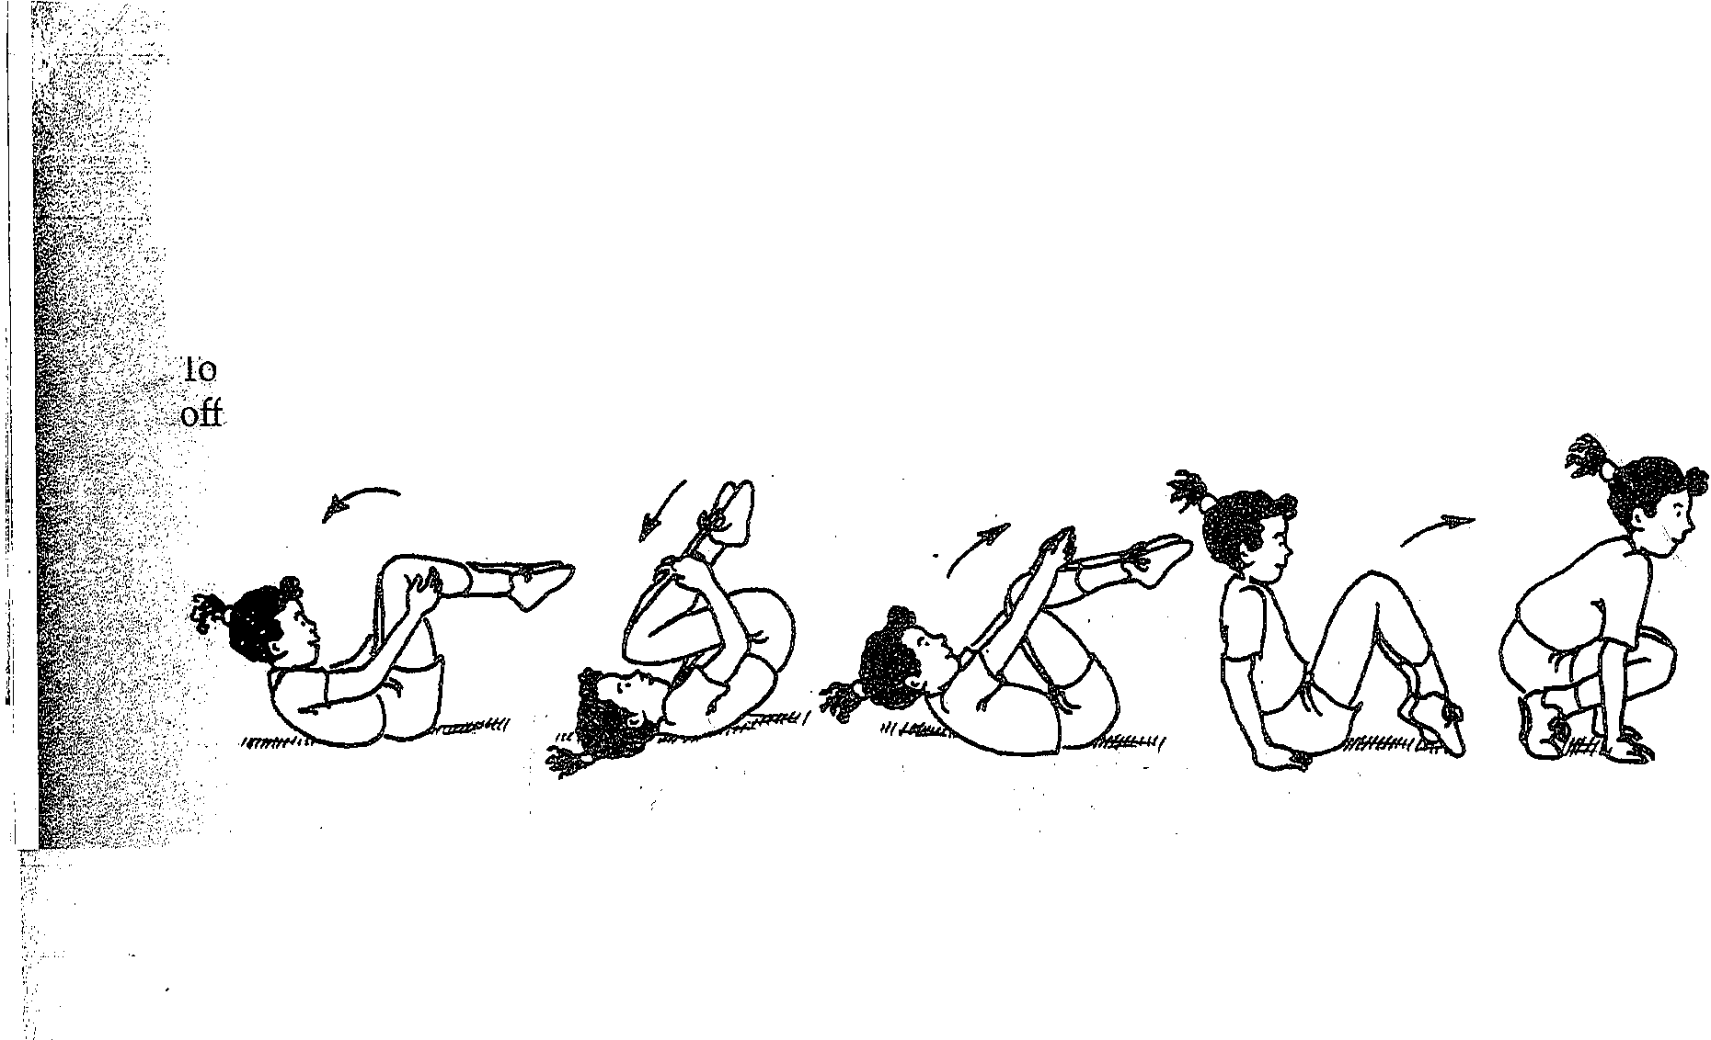\:" ..

---•-•-··•----•-- 37. Back rocker to stand
. ': The student rocks backward and forward on her back. As she rocks
· forward, sh: ss
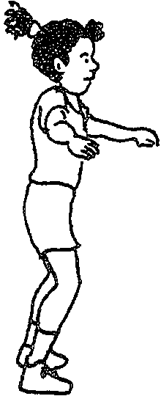 stands up, frmshmg m the T-stand. ""'
< Teaching Tip
- make thisskill more difficult, ask students not to use their hands to push
the floor. -

85. Frog jump uphill (feet together)
Starting in a tucked position, feet together and hands on a bench or raised platform, the student leans forward. While transferring weight from feet to hands, the student jumps his feet forward to tuck stand with his feet near
or inside his hands.





