-=-- -----"-CO--===--=--=-=--::-:-_::-::_ -=--=--::--:-:.:.C: -=--- - ------ ----
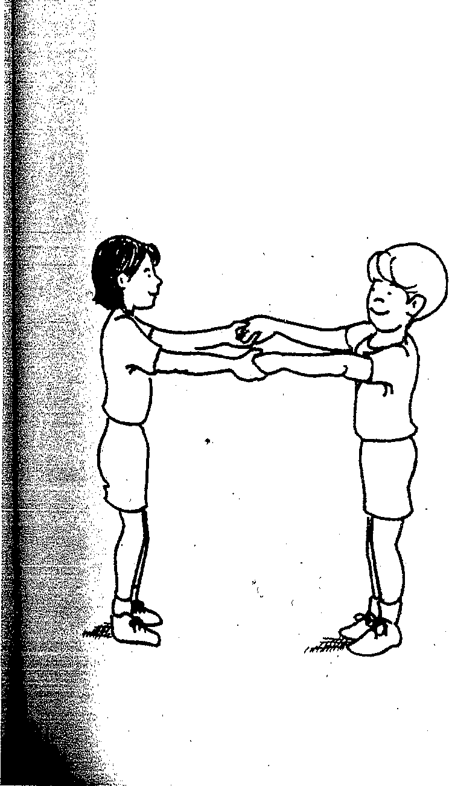75. Couple jumping

Two students stand facing each other holding hands. One student stands while the other jumps up and down continuously in the same place,
··-· _ extending his legs in the air and bending them upon landing. The students ·
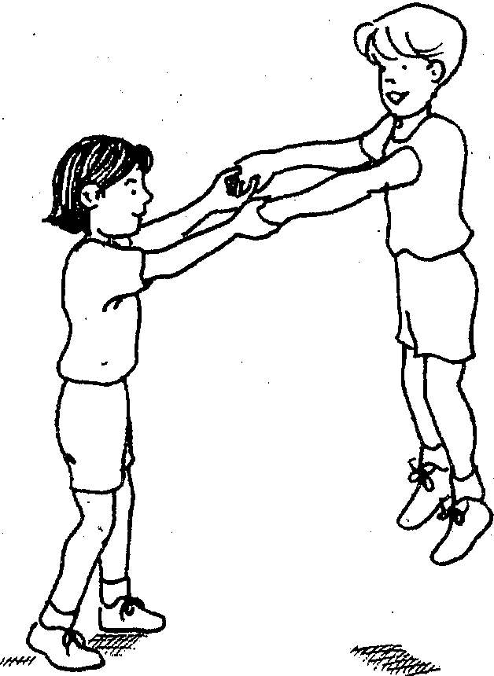take turns repeating the activity.

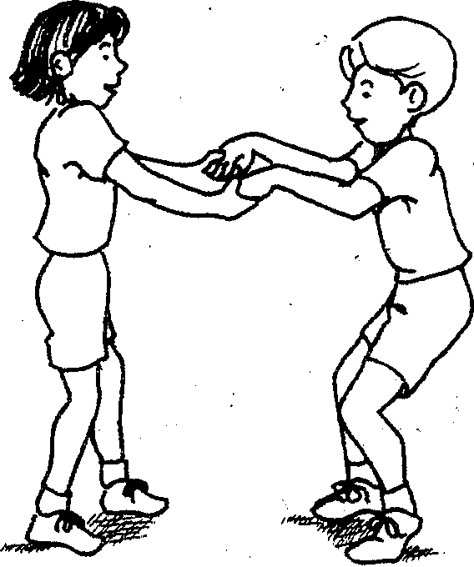

(
·. I - --_,

.·->---- -----------

TUMBLING PRINCIPLES AND SKILLS 17

--- : 30. ;front su:pp:ort to straddle stand

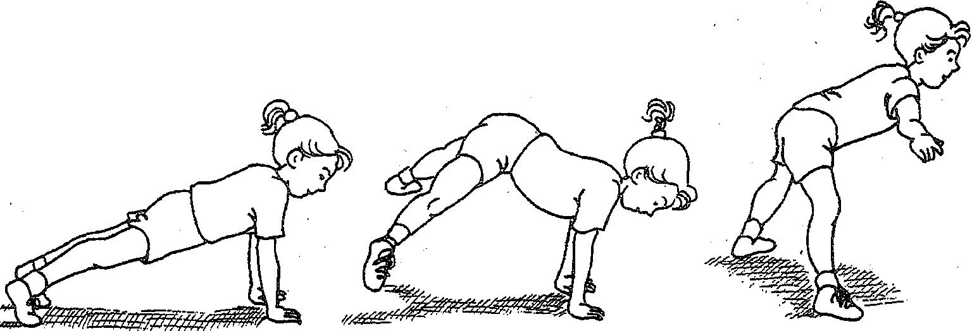>,Stg
_ _ tostraddle stand: The student should hold the legs straight and apart and
_ fh armshorizontal
:<b:ody should bend 90 degrees at the hip.

