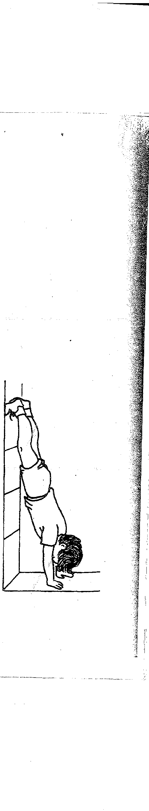//: v:: < - •
_
--- -- .._..;:" _ ....:....·

23. Wall walk to hand.stand \'\:
"'""
'\ "'<-
The student starts in a front support position with toes tottcl:i:ing a wall. Then
the student walks up the wall with each foot and walks toward the wall with his hands. Finish in a "near" handstand position, with hands about one foot
away from the wall. Hold for two seconds, then reverse the technique (walk down the wall with the feet and away from the wall with the hands). Make sure that students walk_·(not d!OP) their feet down the wall.
Drill
Using chalk or tape, draw four horizontal lines, each one foot higher than
the other (start at floor level). Each student should walk up the wall to the first line, then walk down the wall. Next, they should walk up to the second line, theri. down, and so on until they can walkup to but no farther than the fourth line. For some stUdents the tpird line will be the highestthey can walk
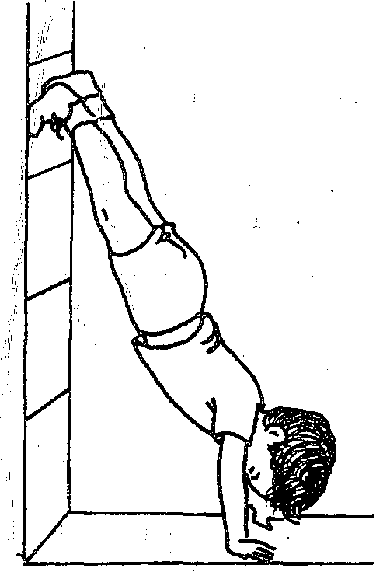without moving their hands closer than one foot from the wall.

